INSTYTUT TECHNIKI BUDOWLANEJ  PL 00-611 WARSZAWA, ul. Filtrowa 1, www.itb.pl | Member of EOTA and UEAtc

National Technical Assessment ITB-KOT-2018/0509 1st Edition

This National Technical Assessment has been issued in accordance with the Regulation of the Minister of Infrastructure and Construction of 17 November 2016 on national technical assessments (Official Journal of the Republic of Poland of 2016, pos. 1968) by Instytut Techniki Budowlanej in Warsaw, upon a request of

„GAMRAT WPC” Sp. z o.o.

ul. Mickiewicza 108, 38-200 Jasło

National Technical Assessment ITB-KOT-2018/0509 1st Edition is a positive assessment of the performance of the following construction product for its intended use:

Set of terrace boards and supplementary elements of the GAMRAT System

Date of expiry of the National Technical Assessment:
July 6, 2023

Warsaw, July 6, 2018

The Document of National Technical Assessment ITB-KOT-2017/0509, first edition, contains 15 pages, including 2 Annexes. The text of this document may only be copied in its entirety. Any publication or dissemination in any other form of excerpts from the text of the National Technical Assessment shall require written agreement with Instytut Techniki Budowlanej. The National Technical Assessment ITB-KOT-2018/0509, first edition, concerns products covered by the Technical Approval ITB AT-15-9705/2016.

Instytut Techniki Budowlanej
ul. Filtrowa 1, 00-611 Warszawa
Phone: 22 825 04 71; NIP: 525 000 93 58; KRS: 0000158785

- TECHNICAL DESCRIPTION OF THE PRODUCT

The subject of the National Technical Assessment is a set of terrace boards and supplementary elements of the GAMRAT System (product type designation), manufactured by "GAMRAT WPC" Sp. z o.o., ul. Mickiewicza 108, 38-200 Jasło, in a manufacturing plant in Poland.
The set of terrace boards and supplementary elements of the GAMRAT System includes the following products:
- Terrace boards made of wood flour and polyvinyl chloride (PVC) composite with modifying additives, manufactured using the coextruding method: with a cross-section of 140 x 25 mm, with grooves on one side, according to Fig. A1, with a linear mass of 2.4 kg/m ± 10% according to PN-EN 15534-1:2014 and with a cross-section of 160 x 25 mm according to Fig. A2, with a linear mass of 2.8 kg/m ± 10% according to PN-EN 15534-1:2014. Terrace boards are 2.4, 3.0 and 4.0 m long. Boards of different lengths may also be delivered, upon agreement between the manufacturer and the customer. The boards are available with brushed (fine or coarse brushing) or non-brushed surface.
- Mounting profiles (joists) made of wood flour and polyvinyl chloride (PVC) composite with modifying additives, with a cross section of 50 x 30 mm, according to Fig. A3, with a linear mass of 1.0 kg/m ± 10% according to PN-EN 15534-1:2014. The mounting profiles are 2.4, 3.0 and 4.0 m long. Profiles of different lengths may also be delivered, upon agreement between the manufacturer and the customer.
- Supplementary elements:
- finishing profiles made of wood flour and polyvinyl chloride (PVC) composite with modifying additives, with a cross-section of 60 x 6 mm, according to Fig. A4;
- L finishing profiles made of wood flour and polyvinyl chloride (PVC) composite with modifying additives, with a cross-section of 60 x 35 mm, according to Fig. A5;
- aluminium finishing profiles, with a cross-section of 35 x 35 mm and 30 x 55 mm, according to Fig. A6, made of aluminium alloy EN AW-606060 or EN AW-6063 according to the standard PN-EN 573-3:2014, temper T66 according to the standard PN-EN 515:2017 and protected against corrosion with an anodic oxide coating with a thickness of not less than 15 µm, meeting the Technical Requirements of the OUALANOD Quality Mark;
- mounting clips, made of high density polyethylene (PEHD), according to Fig. A7;
- mounting clips, made of stainless steel grade 1.4301 (X5CrNi18-10) according to PN-EN 10088-1:2014, according to Fig. A8;
- start clips made of stainless steel grade 1.4301 (X5CrNi18-10) according to PN-EN 10088-1:2014 standard according to Fig. A9.
The shape and dimensions of the products included in the GAMRAT set are given in Annex A. Deviations of dimensions without individual tolerance indications for composite and plastic supplementary elements correspond to the tolerance class v according to PN-EN 22768-1:1999, and for steel supplementary elements to the tolerance class m according to PN-EN 22768-1:1999.

2. THE INTENDED APPLICATION OF THE PRODUCT

The set of terrace boards and supplementary elements of the GAMRAT system is intended for making outdoor floors (terraces, verandas, balconies, platforms, surfaces around outdoor pools, etc.).
The GAMRAT system terrace boards are laid on mounting profiles (joists), spaced no more than 50 cm apart, with a distance of 5 ÷ 10 mm from walls and other fixed elements, e.g. columns. The joists are fixed to a stable base by means of anchoring elements in such a way as to allow water to drain between the joists. The terrace boards are attached to the joists using start and mounting clips and self-drilling screws in accordance with the manufacturer's instructions.

The method of making floors with the GAMRAT set is shown in Appendix B. The products covered by this National Technical Assessment should be used in accordance with the technical design developed for a specific object taking into account the following:
- requirements of Polish standards and technical and construction regulations, in particular the Regulation of the Minister of Infrastructure of 12 April 2002 on technical conditions to be met by buildings and their location (Journal of Laws of the Republic of Poland of 2015, item 1422, as amended),
- assembly instructions prepared by the manufacturer and supplied to customers with each batch of products,
- provisions of this National Technical Assessment.

3. PERFORMANCE PROPERTIES OF THE CONSTRUCTION PRODUCT AND METHODS OF THEIR ASSESSMENT

3.1 Performance properties of the product

The performance properties of the terrace boards and supplementary elements of the GAMRAT system and floors made with the GAMRAT set are given in Table 1.
Table 1
Item | Basic characteristics | Performance properties |  | Test methods
1 | 2 | 3 |  | 4
1 | Dimensional deviations, mm:  - length  - width  - total thickness  - facing wall thickness | (−0 / +10)  ± 1.0  ± 1.0  ± 0.5 |  | PN-EN 15534-1:2014  PN-EN 15534-4:2014
2 | Edge straightness, mm/m | ≤ 0.7
3 | Transverse curvature, mm | ≤ 0.7
4 | Resistance to impact, energy 7 J: | at −20°C | at +20°C | PN-EN 15534-1:2014  PN-EN 15534-4:2014
 | - a board with a cross-section of 140 x 25 mm | No cracks ≥ 10 mm long; permanent indentation ≤ 0,5 mm deep allowed
 | - a board with a cross-section of 160 x 25 mm
5 | Flexural properties:  - load of rupture, N | average value ≥ 3300  where a single result ≥ 3000 |  | PN-EN 15534-1:2014  PN-EN 15534-4:2014  (span of supports, 500 mm)
 | - deflection under a load of 500 N, mm | average value ≤ 2  where a single result ≤ 2,5
 | - bending strength, MPa | ≥ 33
 | modulus of elasticity in bending, MPa:  - board with a cross section of 140x25 mm | ≥ 4600
 | - board with a cross section of 160 x 25 mm | ≥ 4600
6 | Moisture resistance under cyclic test conditions determined by a decrease of bending strength, % | average value ≤ 20  where a single result ≤ 30 |  | PN-EN 15534-1:2014  PN-EN 15534-4:2014
7 | Swelling after 28 days, %:  - in length | average value ≤ 0.4  single value ≤ 0.6
 | - in width | average value ≤ 0.8  single value ≤ 1.2
 | - in thickness | average value ≤ 4.5  single value ≤ 5.0
8 | Water absorption after 28 days in water bath, % | average value ≤ 6.0  single value ≤ 6.0

Table 1, continued
Item | Basic characteristics | Performance properties | Test methods
1 | 2 | 3 | 4
9 | Resistance to ageing determined by rating the difference of colour after 300 h of exposure | ≤ 5 | PN-ISO 7724-2:2003  PN-ISO 7724-3:2003  PN-EN ISO 4892-2:2013 (method A)  PN-EN 15534-4:2014
10 | Dimensional stability, % as determined by the change after 24 hours of storage at the temperature of:  - +70°C | ≤ 0.2 | p. 3.2.1  (change in length and width)
 | - −20°C | ≤ 0.2
11 | Pull-through resistance (joist - clip - screw), MPa | ≥ 25 | PN-EN 15534-1:2014  PN-EN 15534-4:2014
12 | Impact resistance of floor covering, Nm | ≥ 500 | PN-EN 1195:1999 (bag of 25 kg and 250 mm in diameter, impact on centre span)
13 | Slip resistance PTV:  - dry surface | ≥ 90 | PN-EN 15534-1:2014  PN-EN 15534-4:2014  CEN/TS 15676 (lengthwise)
 | - wet surface | ≥ 55
14 | Reaction to fire classification, class | B_{fl}-s1*⁾ | PN-EN 13501-1+A1:2010
*⁾ classification applies to floorings on non-flammable substrates (at least class A2-s3, d0 reaction to fire according to PN-EN 13501-1+A1:2010)

- Methods used to assess the performance

The assessment methods are given in Table 1 and in paragraph 3.2.1.

3.2.1. Examination of dimensional stability (changes in linear dimensions). The test is carried out on samples of 300 mm long terrace boards which, after measuring the distance at the indicated measuring points, are exposed to:
- temperature of +70°C during 24 hours,
- temperature of −20°C during 24 hours.
The samples are then conditioned for 2 hours under laboratory conditions. The change of linear dimensions is calculated according to the formula:

where:
l₁ – final measurement, i.e. after exposure to temperatures: +70°C and −20°C, mm
l₀ – initial measurement, mm.

4. PACKAGING, TRANSPORT AND STORAGE AND THE WAY IN WHICH THE PRODUCT IS MARKED

Products included in the GAMRAT set should be delivered in original manufacturer's packaging and stored and transported in such a way as to ensure that their technical properties remain unchanged.
The manner of marking the products with the construction mark shall be in accordance with the Regulation of the Minister of Infrastructure and Construction of 17 November 2016 on the manner of declaring the functional properties of construction products and the manner of marking them with the construction mark (Journal of Laws of the Republic of Poland of 2016, item 1966, as amended).

Product marking with a construction mark should be accompanied by the following information:
- the last two digits of the year in which the construction mark was first placed on the construction product;
- the name and address of the manufacturer’s registered office or an identification mark allowing explicit identification of the name and address of the manufacturer’s registered office;
- the name and type designation of the construction product;
- the number and year of issue of the national technical assessment, which served as the basis for the declaration of performance; (ITB-KOT-2018/0509 1st edition);
- the number of the national declaration of performance;
- the level or class of the declared performance;
- the address of the manufacturer's website, if the national declaration of performance is made available on that website.
A safety data sheet and/or information on hazardous substances contained in a construction product referred to in the Articles 31 or 33 of Regulation (EC) No. 1907/2006 of the European Parliament and of the Council on the Registration, Evaluation, Authorisation and Restriction of Chemicals (REACH), establishing a European Chemicals Agency, should be provided or made available together with the national declaration of performance, as appropriate.
Moreover, the marking of a construction product, being a hazardous mixture according to the REACH regulation, should comply with the requirements of Regulation (EC) No. 1272/2008 of the European Parliament and of the Council on classification, labelling and packaging of substances and mixtures (CLP), amending and repealing Directives 67/548/EEC and 1999/45/EC, and amending Regulation (EC) No. 1907/2006.

5. ASSESSMENT AND VERIFICATION OF CONSTANCY OF PERFORMANCE

- National system for the assessment and verification of the constancy of performance

In accordance with the Regulation of the Minister of Infrastructure and Construction of November 17, 2016 on the manner of declaring the performance characteristics of construction products and the manner of marking them with a construction mark (Official Journal of the Republic of Poland of 2016, pos. 1966, as amended), the System 4 of AVCP is applicable.

- Type testing

The performance characteristics assessed in the section 3 constitute the product type testing until there are changes in raw materials, constituents, production line or plant.

- Factory production control

At the manufacturing plant the manufacturer shall have implemented a factory production control system. All the elements, requirements and provisions adopted by the manufacturer for the system shall be documented in a systematic manner in the form of written policies and procedures, including test records. The factory production control shall be adapted to the manufacturing processes and ensure the achievement of the declared performance properties of the product in serial production.
The factory production control includes the specification and verification of raw materials and constituents, controls and tests to be carried out during manufacture and control tests (according to point 5.4), conducted by the manufacturer in accordance with the established test plan and according to the principles and procedures specified in the FPC documentation.

The results of production control shall be recorded on a regular basis. The records of the register should show whether the products has satisfied the criteria of the assessment and verification of the constancy of performance. Individual products or batches of products and related manufacturing details shall be fully identifiable and traceable.

5.4. Control tests

5.4.1. Test plan. The test plan shall include:
a) ongoing tests,
b) periodic tests.

5.4.2. Ongoing tests. Ongoing tests shall include inspection of:
a) dimensional deviations,
b) edge straightness,
c) transverse curvature,
d) linear mass.

5.4.3. Periodic tests. Periodic tests shall include a test:
a) resistance to impact,
b) flexural properties,
c) swelling,
d) water absorption,
e) slip resistance of flooring,
f) pull-through resistance of fasteners (withdrawal strength of fasteners).

5.5. Frequency of tests
The ongoing tests should be conducted in accordance with the prescribed test plan, but not less frequently than for each batch of products. The size of a batch of products should be specified in the documentation of factory production control.
Periodic tests should be performed at least once every 3 years.

6. INSTRUCTIONS

6.1. The National Technical Assessment ITB-KOT-2018/0509 1st edition is a positive assessment of the performance of those essential characteristics of the terrace board set and supplementary elements of the GAMRAT system which, in accordance with the intended use, resulting from the provisions of the Assessment, influence the fulfilment of basic requirements by the construction objects in which the product will be applied.

6.2. The National Technical Assessment ITB-KOT-2018/0509 1st edition is not a document authorizing to mark a construction product with a construction mark.
Pursuant to the Act on Construction Products of April 16, 2004, as amended (consolidated text: Journal of Laws of 2016, item 1570), a set to which this National Technical Assessment applies may be marketed or made available on the domestic market, if the manufacturer has assessed and verified the constancy of performance, drawn up a national declaration of performance in accordance with the ITB-KOT-2018/0509 National Technical Assessment 1st edition and marked the products with a construction mark in accordance with the applicable regulations.

6.3. The National Technical Assessment ITB-KOT-2018/0509 1st edition does not infringe the rights resulting from the provisions on industrial property protection, in particular the Act of June 30, 2000 – Industrial Property Law (consolidated text: Journal of Laws of 2013, item 1410, as amended). Ensuring these rights is the responsibility of the users of this ITB National Technical Assessment.

6.4. When issuing a National Technical Assessment, ITB shall not be held responsible for any possible infringement of exclusive and acquired rights.

6.5. The National Technical Assessment does not release the manufacturer of products from responsibility for their proper quality, and the contractors of construction works from responsibility for their proper use.

6.6. The validity of this National Technical Assessment may be extended for further periods not exceeding 5 years.

7. A LIST OF DOCUMENTS USED IN THE PROCEEDINGS

7.1. Reports, test reports, evaluations, classifications

1) LK00-02932/15/ZOONK. Test report concerning the set of terrace boards and supplementary elements of the GAMRAT system. Building Elements Engineering Department, Building Research Institute (ITB), Warsaw.
2) 02932/15/ZOONK. Research work on the set of terrace boards and supplementary elements of the GAMRAT system. Building Elements Engineering Department, Building Research Institute (ITB), Warsaw.
3) 01741/15/R2ONM. Research report on GAMRAT composite profiles. Construction Materials Engineering Department, Building Research Institute (ITB), Warsaw.
4) 01741/15/R18NP. Classification report of reaction to fire according to PN-EN 13501-1+A1:2010. Fire Research Department, Building Research Institute (ITB), Warsaw.
5) LPP01-01741/15/R18NP and LPP02-01741/15/R18NP. Test reports on WPC terrace profiles. Fire Testing Laboratory, Building Research Institute (ITB), Warsaw 2015.
6) 172/118/2015/2. Study report on Gamrat composite boards. "Gamrat" Spółka Akcyjna Centrum Jakości, Jasło, 26.10.2015.
7) 172/118/2015/3. Study report on Gamrat composite boards. "Gamrat" Spółka Akcyjna Centrum Jakości, Jasło, 26.10.2015.

7.2. Related standards and documents

PN-EN 515:2017 | Aluminium i stopy aluminium. Wyroby przerobione plastycznie.- Oznaczenia stanów  (Aluminium and aluminium alloys. Wrought products. Temper designations)
PN-EN 573-3:2014 | Aluminium i stopy aluminium. Skład chemiczny i rodzaje wyrobów przerobionych plastycznie. Część 3: Skład chemiczny i rodzaje wyrobów  (Aluminium and aluminium alloys. Chemical composition and form of wrought products. Chemical composition and form of products)
PN-EN 1195:1999 | Konstrukcje drewniane. Metody badań. Zachowanie się konstrukcyjnych poszyć podłogowych  (Timber structures. Test methods. Performance of structural floor decking.)
PN-EN 10088-1:2014 | Stale odporne na korozję. Część 1: Wykaz stali odpornych na korozję  (Stainless steels. List of stainless steels)
PN-EN 13501-+A1:2010 | Klasyfikacja ogniowa wyrobów budowlanych i elementów budynków. Część 1: Klasyfikacja na podstawie wyników badań reakcji na ogień  (Fire classification of construction products and building elements. Classification using data from reaction to fire tests)
PN-EN 15534-1:2014 | Kompozyty wytworzone z materiałów na bazie celulozy i tworzyw termoplastycznych (powszechnie zwane kompozytami polimerowo- drzewnymi (WPC) lub kompozytami z włóknem naturalnym (NFC)). Część 1: Metody badań przeznaczone do charakteryzowania mieszanin i wyrobów  (Composites made from cellulose-based materials and thermoplastics (usually called wood-polymer composites (WPC) or natural fibre composites (NFC)). Test methods for characterisation of compounds and products)
PN-EN 15534-4:2014 | Kompozyty wytworzone z materiałów na bazie celulozy i tworzyw termoplastycznych (powszechnie zwane kompozytami polimerowo- drzewnymi (WPC) lub kompozytami z włóknem naturalnym (NFC)). Część 4: Specyfikacje profili podłogowych i płytek  (Composites made from cellulose-based materials and thermoplastics (usually called wood-polymer composites (WPC) or natural fibre composites (NFC)). Specifications for decking profiles and tiles)
PN-EN ISO 4892-2:2013 | Tworzywa sztuczne. Metody ekspozycji na laboratoryjne źródła światła. Część 2. Lampy ksenonowe łukowe  (Plastics. Methods of exposure to laboratory light sources. Xenon-arc lamps)
PN-ISO 7724-2:2003 | Farby i lakiery -- Kolorymetria -- Część 2: Pomiar barwy  (Paints and varnishes -- Colorimetry -- Part 2: Colour measurement.)
PN-ISO 7724-3:2003 | Farby i lakiery -- Kolorymetria -- Część 3: Obliczanie różnic barwy  (Paints and varnishes -- Colorimetry -- Part 3: Calculation of colour differences)
CEN/TS 15676 | Wood flooring. Slip resistance. Pendulum test
AT-15-9705/2016 | Zestaw desek i profili tarasowych oraz elementów uzupełniających  systemu GAMRAT  (Set of terrace boards and profiles and supplementary elements of the GAMRAT system)

APPENDIXES

Appendix A. Shape and dimensions of the products included in the set of terrace boards and supplementary elements of the GAMRAT system 10
Appendix B. Installation method of floor made of the GAMRAT set 14

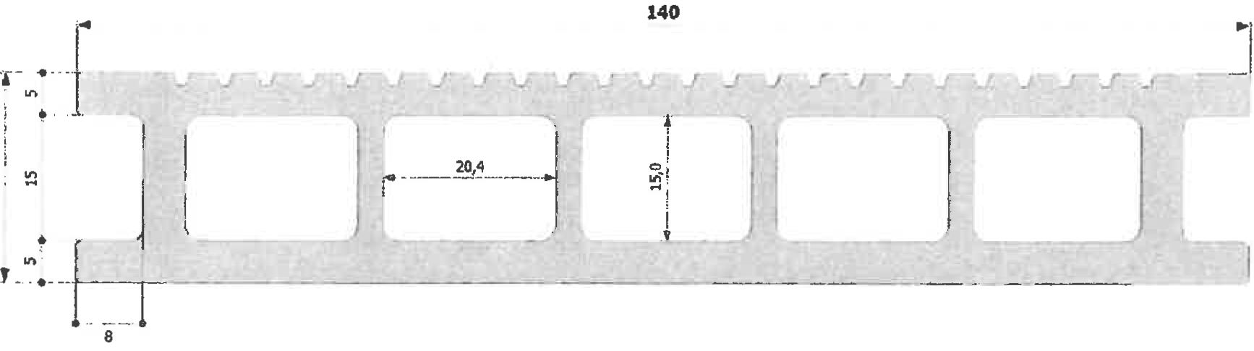

Figure A1. Terrace board 140 x 25 mm
(dimensions in mm)

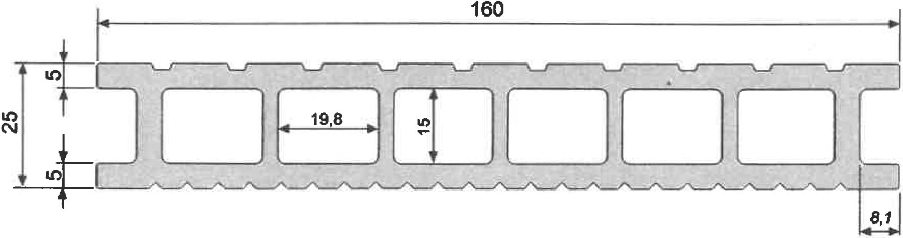

Figure A2. Terrace board 160 x 25 mm
(dimensions in mm)

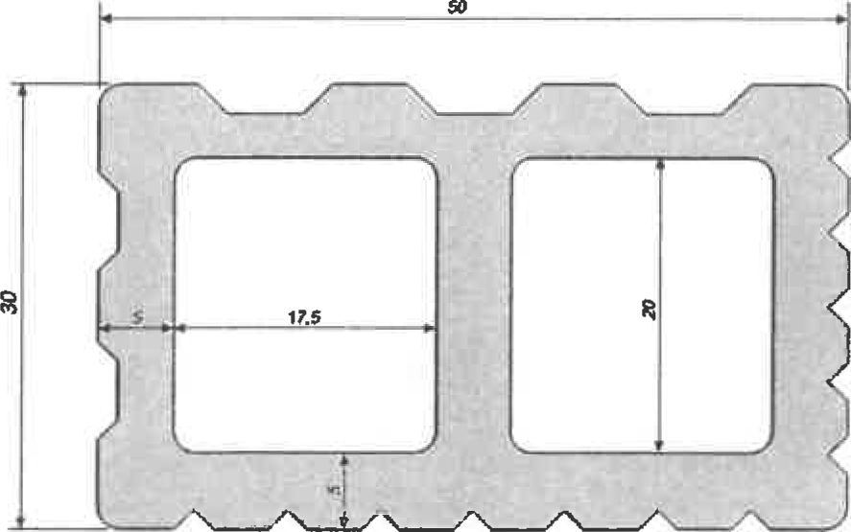

Figure A3. Joist
(dimensions in mm)

Figure A4. Composite finishing profile
(dimensions in mm)

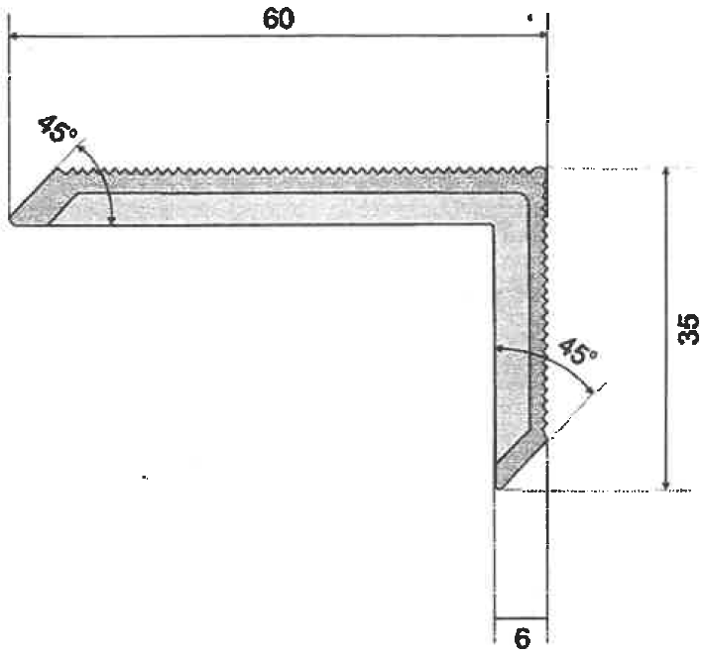

Figure A5. Composite corner profile
(dimensions in mm)

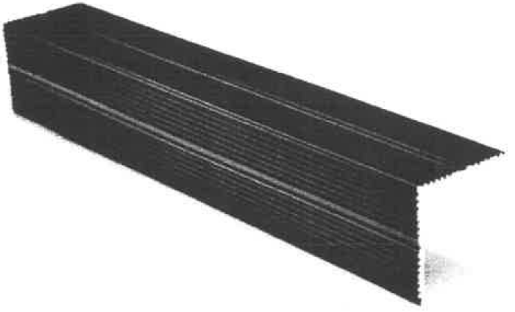

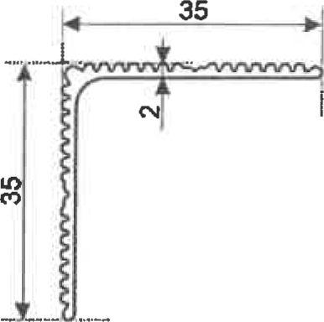

Figure A6. Aluminium finishing profile
(dimensions in mm)

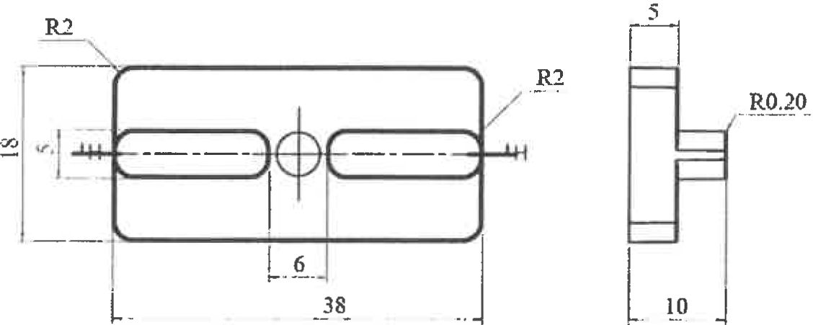

Figure A7. PEHD mounting clip
(dimensions in mm)

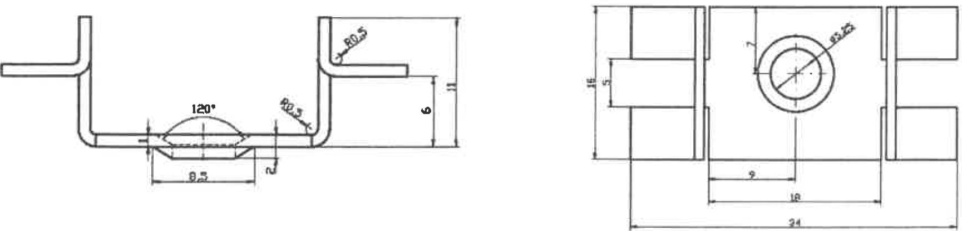

Figure A8. Stainless steel mounting clip
(dimensions in mm)

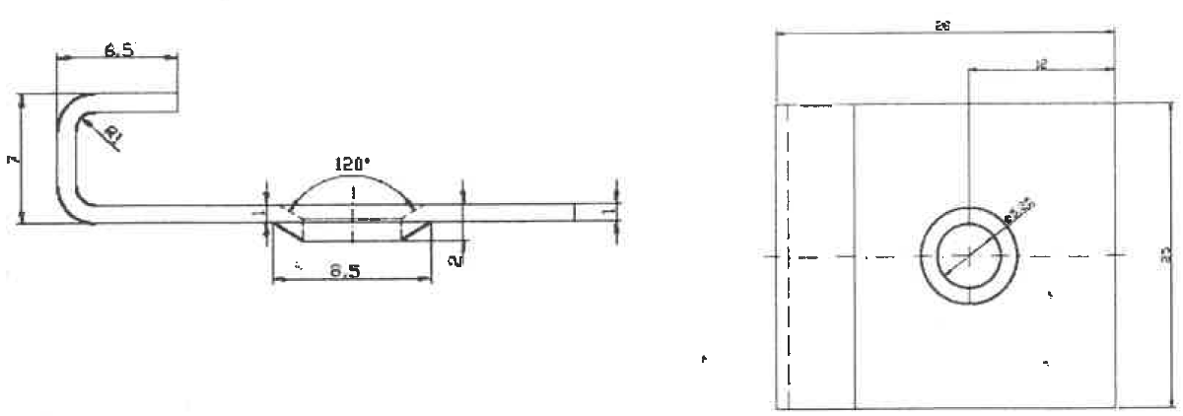

Figure A9. Stainless steel start clip
(dimensions in mm)

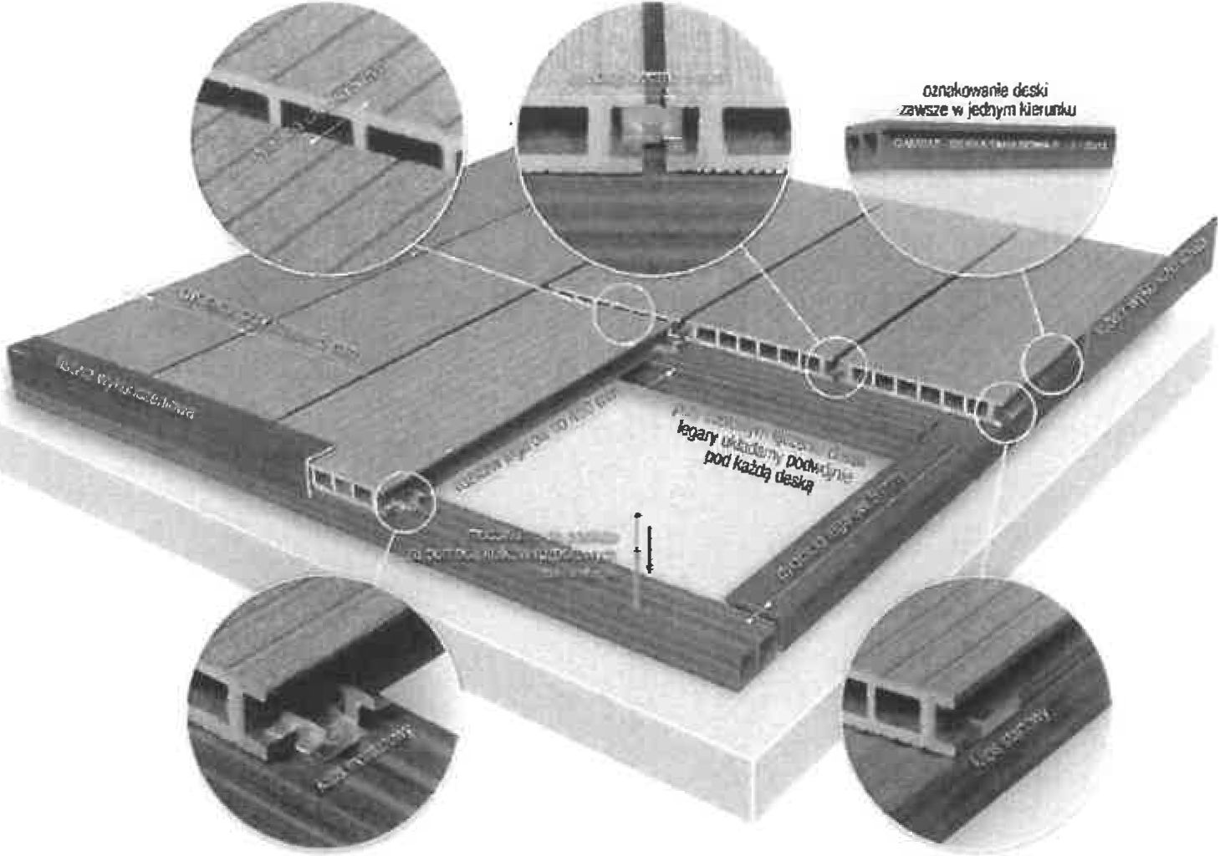

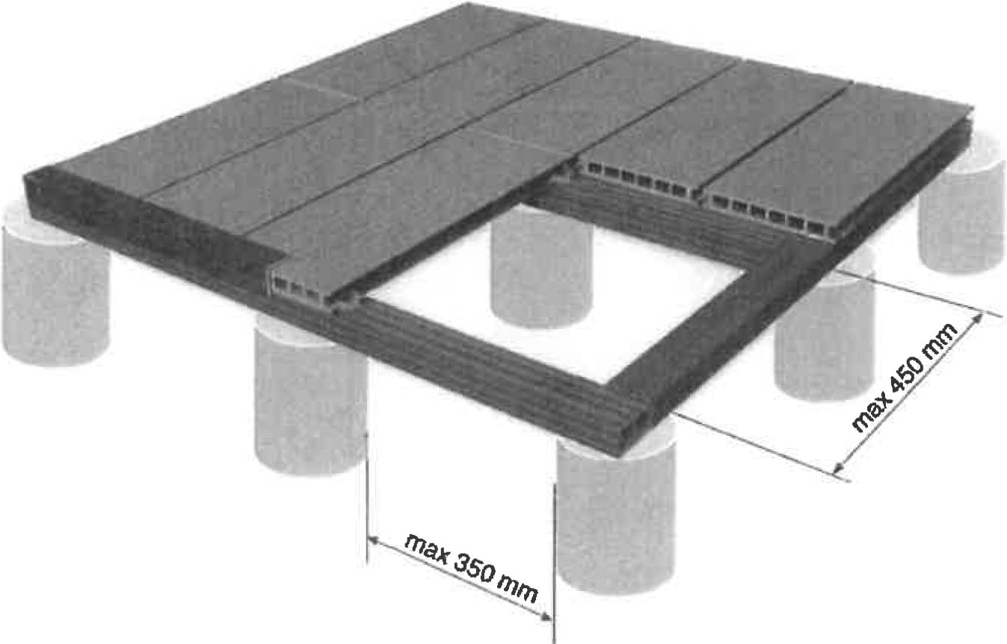

Figure B1. Installation layout of flooring made of GAMRAT set

